**AngularJS, Typescript, Bootstrap assignment**

**PART: 1**

Design one employee entity with fields such as

1. First Name
2. Last Name
3. Email
4. Date of Joining
5. Extension
6. isOnBench
7. Prepare mock json data containing array of above employee entity. Put data in json file.
8. Display that array in tabular format. (Note : Use bootstrap css classes wherever necessary)

**PART: 2**

1. Sorting of data in table (Column wise). When user will click on header of any column then data in table should be sorted according to that column. e.g. If user clicks on **FirstName** header then all data should be sorted according to **FirstName**. (First click on header will sort data in ascending order second click should sort in descending order).
2. Right now isOnBench attribute will be Boolean so in table it will be displayed like. See **on Bench** column values are displayed as **true**, **false** but we want to display it like **YES** and **NO i.e.** if value is **true** then will display as **YES** and if value is **false** then we will display as **NO**. So think on it what you can do to achieve the same.

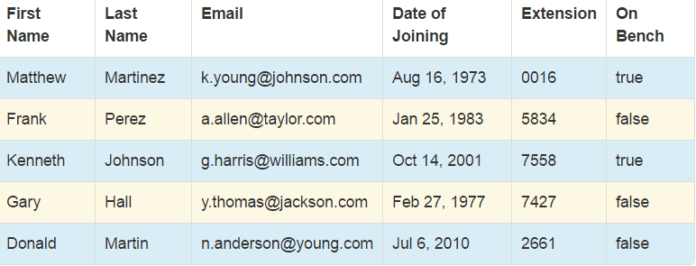

**PART: 3**

1. Add one Edit/Delete action column in table. As shown in below screen shot :

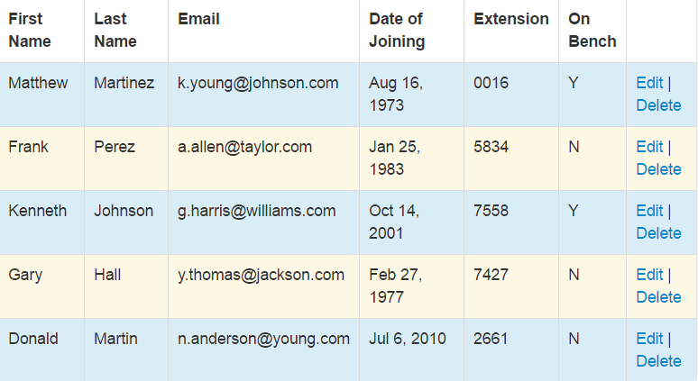

1. When user will click on edit his details should be shown in one form with Update button, where he can update details, once he will click update he should be redirected again to table view where he will see his updated details.
2. When user will click on Delete one modal dialog should open which will show confirmation message **Are you sure you want to delete record?** With two buttons **OK** and **CANCEL**. If user clicks on OK then record should be deleted and modal dialog should be dismissed, if he clicks on CANCEL record should not be deleted and dialog should be dismissed.(Note : Use angular UI bootstraps Modal dialog feature for the same).

**PART: 4**

Adding employee in existing table.

1. Add one Add Employee button wherever you find its position suitable e.g.

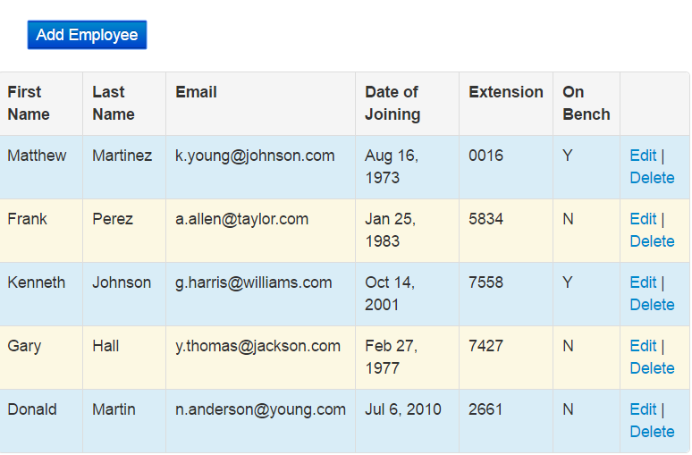

1. When user will click on Add Employee one form should open with text fields for FirstName, LastName,Email,extension Datepicker for Date Of Joining ,radio button for On Bench, and one submit button. When user will click on submit data should be added to existing table. (**Note:** All are required fields and add bootstrap css classes as well as controls wherever needed).